June 20th, 2010
Hi
I think I have mentioned in the past that there is a problem with the bathroom and kitchen extraction systems in that they let cigarette smoke and cooking smells from other rooms enter. Well, I have not had the problem for a long time but it returned last Sunday though just for one day. And it is back again today. By turning on the extraction fans, the smoke and smells can be removed, but the fans are noisy and I do not like to leave them on especially when I go out. The hotel knows of the problem and turns on a roof extraction far for several hours a day, which works but only while they are on. They are not on all day as they too are noisy and can be heard, even as far down as my suite.
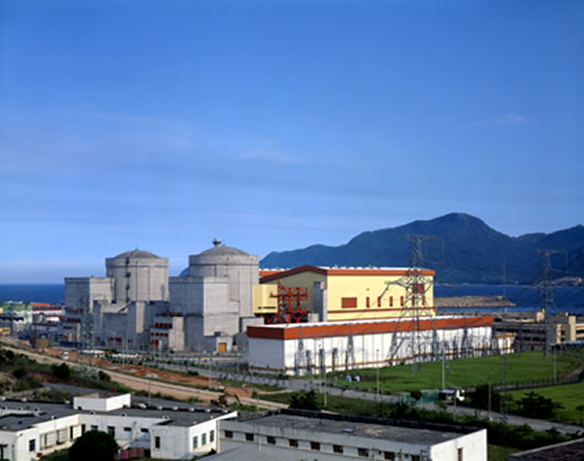
A radiation leak at the Daya Bay nuclear power station was reported the other day, about one month after it happened!! It was only a minor leak and the HK Observatory, which has radiation monitors around the territory, did not detect anything unusual. Still, it is worrying, as many in HK commented, that no announcement was made, given the sensitivity of people to nuclear power. The announcement eventually came, not from China, but from China Light and Power Company, which has 25% ownership. You can probably remember that at CUHK, where we used to live, the power station is only 30 km away and the prevailing wind is from that direction so the radiation from any major accident would reach there first.
On the AOL news (on closing the e-mail) there was an item that aspirin can exacerbate asthma! Nana used to take aspirin regularly to keep her blood thin.
There was a report from HKU the other day indicating that the genetic structure of the H1N1 virus in pigs has changed. Doesn't seem to be serious though needs to be watched. Apparently, pigs are a 'mixing pot' for the genes of H1N1 (??and other viruses).
On Thursday evening, the debate on the government's electoral reform package between the CE and a member of the pro-democracy Civic Party took place. Even though it was in Cantonese, I still watched it. The two participants each answered questions that had been selected from those sent in by the public. The Civic Party person, a barrister who is good at debating, 'won' the debate easily, according to every commentator . People have puzzled why the CE wanted to take her on, knowing her debating ability, and also as she was one of the architects of the recent unnecessary 'referendum' elections. There was no audience for the debate as the CE was worried that there might be disturbances. The vote for the electoral package will be on Wednesday. All the pro-democracy parties have in the past said they would vote against it as it is (correctly) short on specifics. However, just this week the Democracy Party said it may support the package as China and the pro-Beijing parties have agreed to changes it suggested. This relates to the government's plan to introduce five more 'functional' constituencies, one for each of the five district councils. The original government plan was, as with all other functional constituencies, limited the elections only to those in the sector, in this case, just the district councillors. The Democratic Party suggested instead that everyone who does not already have a functional constituency vote (which includes me now that I no longer have a vote for the Education functional constituency) be allowed to vote. This proposal seems now to have been accepted. But it is interesting how all the pro-Beijing people who for long opposed this now have a change of view; it is obvious who gave them this change!! Still, people wonder why there is this pro-democracy support for five more functional constituencies, albeit it with universal vote, when the same parties want to see all functional constituencies abolished (as they are only small-group elections rather than being universal! Could they be falling into some electoral trap?
There was quite a lot of international Rugby yesterday. The ABs beat Wales 42-9 in Dunedin. Last weekend, Daniel Carter (pictured) passed the 1000 point mark and is now the third highest Rugby point scorer. I wished I had watched it but completely forgot. England beat the Wallabies 21-20. And the Springboks beat Italy though with some difficulty apparently.
For the last few weeks, I have been writing the letters using the OpenOffice word processor instead of Microsoft Word but saving them in the Microsoft Word .doc format. They should open normally when you open them using Word. Is that the case?
That is it for now.
Cheers

